**Diet: Ray** (skates, abysal, oscelate, southern thornback, sandy magpie, stingrays, striped, masked, wide stingray, coastal)

**Shovelnose rays (family Rhinobatidae)**

**Guitarfish (family Rhynchobatidae)**

**Sawfish (family Pristidae)**

**White-spotted Eagle Ray, Aetobatus narinari**

**Southern Fiddler Ray** They are opportunistic bottom feeders consuming a variety of shelled invertebrates, fish, crabs and worms which are crushed by numerous short blunt teeth.  The fiddler ray grows to a maximum length of 1.4 metres.

Females grew to greater lengths than males, i.e. 1460 *v.* 890 mm, and matured (*L*50) at larger lengths, i.e. 892 *v.* 678mm respectively. As body size increased, teleosts, pilumnid and portunid crabs and molluscs became important dietary components. Overall, the diet consisted predominantly of crustaceans, fish, polychaetes and molluscs, with volumetric contributions of 73.4, 17.2, 5.3 and 2.8% respectively. Dietary composition underwent a cyclical seasonal change and differed among locations, indicating some degree of opportunistic feeding

Major taxa and dietary categories %F %N %V

Crustacea was the main faunal taxon in the diet of *T. fasciata*, thereby paralleling the situation with the five other rhinobatid species for which there are dietary data (Talent 1985; Harris *et al*. 1988; Goitien *et al*. 1998; Kyne and Bennett 2002*a*; White *et al*. 2004). However, the percentage volumetric contribution of this taxon to the components of the diets of *Trygonorrhina fasciata* (73%) was less than its contribution to the corresponding diets of *Rhinobatos productus* (78%) and *Aptychotrema rostrata* (79%) and far less than to those of *R. typus* (97%) and *R. horkelii* (99%).

The volumetric contribution made by teleosts to the diet of *T. fasciata* (17%) fell between those for *A. rostrata* (20%) and *R. productus* (14%) and greatly exceeded the maximum of 2.8% recorded for *R. annulatus*, *R. horkelii* and *R. typus*

Polychaetes were ingested by over 15% of the individuals and contributed over 5% to the dietary volume of *T. fasciata* and were thus a reasonably important component of the diet of this species.

The mollusc component of the diet of *T. fasciata* and *A. rostrata* (both 2.8%) comprised cephalopods, whereas that of *R. productus* (6.6%) consisted of bivalve molluscs and those of *R. typus*, *R. annulatus* and *R. horkelii* were negligible.

Kyne and Bennett (2002*a*) drew attention to the fact that polychaetes and bivalve molluscs were not ingested by *A. rostrata* even though this potential prey was abundant in the environment of this species. The above comparisons among six species of rhinobatids

provides strong circumstantial evidence that, at least in south-western Australian waters, *T. fasciata* feeds on a more diverse suite of prey than the other five rhinobatid species elsewhere. It is particularly noteworthy that *T. fasciata* feeds not only on substantial amounts of different types of crustaceans, but also on a range of benthic teleosts, free-swimming cephalopods and errant polychaetes. The latter taxon, errant polychaetes,

protrudes above the substrate (Fauchald 1977). It is therefore relevant that, unlike those other species, the rostrum of *T. fasciata* is rounded, rather than pointed, and thus does not appear to represent as specialised a mechanism for detecting prey and feeding. The absence of sand grains in the gut contents indicates that this species feeds above the substrate surface.

The benthic fish fauna on the lower west coast of Australia contains four other abundant species of ray, which represent two genera of the Urolophidae (Hyndes *et al*. 1999). The two

*Trygonoptera* species feed to a greater extent on polychaetes, whereas the two *Urolophus* species feed more on crustaceans (Platell *et al*. 1998). However, the relative contributions of

the different prey to the diets of the four species were significantly different from each other. In contrast to the four urolophid species,*T. fasciata* fed far more extensively on teleosts and consumed smaller volumes of polychaetes. Thus, benthic food resources on the lower west coast of Australia are partitioned among the above five species of batoids, which thereby reduces competition for those resources. Furthermore, size related changes in the diets of these species reduce the potential for intraspecific competition for food. In the case of *T. fasciata*, the changes in diet that occurred with increasing body size involved an increase in the consumption of larger and often faster swimming prey, such as teleosts, cephalopods and pilumnid, portunid and xanthid crabs, and a decrease in the ingestion of small prey, such as mysids, isopods, amphipods, carids and pinnotherid crabs. The view that *T. fasciata* is a relatively opportunistic feeder, even though it feeds largely on and above the substrate, is supported by the fact that the dietary compositions of this species differed significantly among regions.Thiswas so marked that the main typifying species for the dietary composition of *T. fasciata* in each regionwas totally different. Such differences presumably reflect marked variations in the potential prey available around Rottnest Island and in Comet Bay and Geographe Bay, which, in turn, are probably related to differences in the water depth of the areas sampled, i.e. *>*30 *v.* 10 *v.* 1–10 m. The conclusion that *T. fasciata* feeds opportunistically is also consistent with our finding that the dietary composition of this species underwent a cyclical change during the year, presumably as a result of changes in the relative abundance of its prey. (Marshall et al 2007)

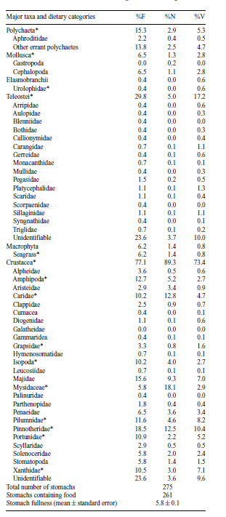

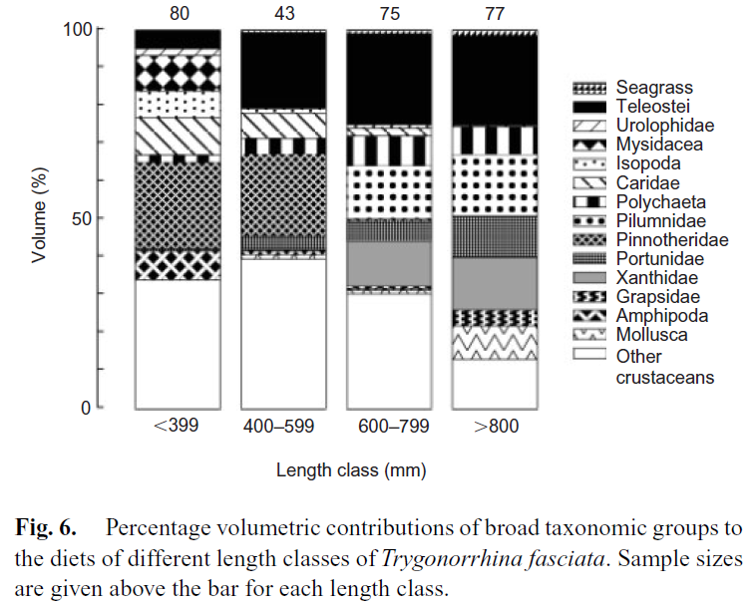

from Marshall et al, 2007

predatory skates: large crustaceans, cephalopods and fishes

Benthophagic skates: amphipods and worms

**Rays> 800 mm**

|  |  |
| --- | --- |
| **prey item** | **probability of consuming** |
| FDTdetritivorous fish | 0.3 |
| FSR Small reef associated | 0.3 |
| FDO Demersal shallow omnivore | 0.3 |
| FMA Demersal macroalgal feeders | 0.3 |
| MAZ Macrozoobenthos big, fast | 0.3 |
| CEP Cephalopods | 0.2 |
| BC Benthic Carnivores | 0.01 |

**Rays 600- 799 mm similar prey but smaller**

|  |  |
| --- | --- |
| **prey item** | **probability of consuming** |
| FDTdetritivorous fish | 0.3 |
| FSR Small reef associated | 0.3 |
| FDO Demersal shallow omnivore | 0.3 |
| FMA Demersal macroalgal feeders | 0.3 |
| MAZ Macrozoobenthos big, fast | 0.3 |
| CEP Cephalopods | 0.2 |
| BC Benthic Carnivores | 0.01 |

**Rays 400-599 mm**

|  |  |
| --- | --- |
| **prey item** | **probability of consuming** |
| BC Benthic Carnivores | 0.1 |
| BG Benthic grazers | 0.1 |
| PRW prawns | 0.05 |
| MAZ Macrozoobenthos small slow | 0.2 |
| FDTdetritivorous fish small | 0.1 |
| FSR Small reef associated | 0.1 |
| FDO Demersal shallow omnivore small | 0.1 |
| FMA Demersal macroalgal feeders small | 0.1 |
| BFF benthic filter feeders | 0.1 |

**Rays< 399 mm**

|  |  |
| --- | --- |
| **prey item** | **probability of consuming** |
| BC Benthic Carnivores | 0.2 |
| BG Benthic grazers | 0.2 |
| PRW prawns | 0.05 |
| MAZ Macrozoobenthos small slow | 0.2 |
| FDTdetritivorous fish | 0.07 |
| FSR Small reef associated | 0.07 |
| FDO Demersal shallow omnivore | 0.07 |
| FMA Demersal macroalgal feeders | 0.07 |
| BFF benthic filter feeders | 0.2 |

Marine and Freshwater Research, CSIRO, 2007, 58, 104-115.  Reproductive biology and diet of the southern fiddler ray, Trygonorrhina fasciata (Batoidea : Rhinobatidae), an important trawl bycatch species, by Lindsay J. Marshall , William T. White and Ian C. Potter.

Orlov, A.M. 1998 The diets and feeding habits of some deep water benthic skates (Rajidae) in the Pacific Waters of the Northern Kuril Islands and Southeastern Kamchatka. Alaska Fishery Bulletin 5(1); 1-17

McAuley,R., Newbound, D., Ashworth, R., 2002. Fiel identification guide to WA sharks and shark like rays. Department of Fisheries, Perth, WA, 25 pp